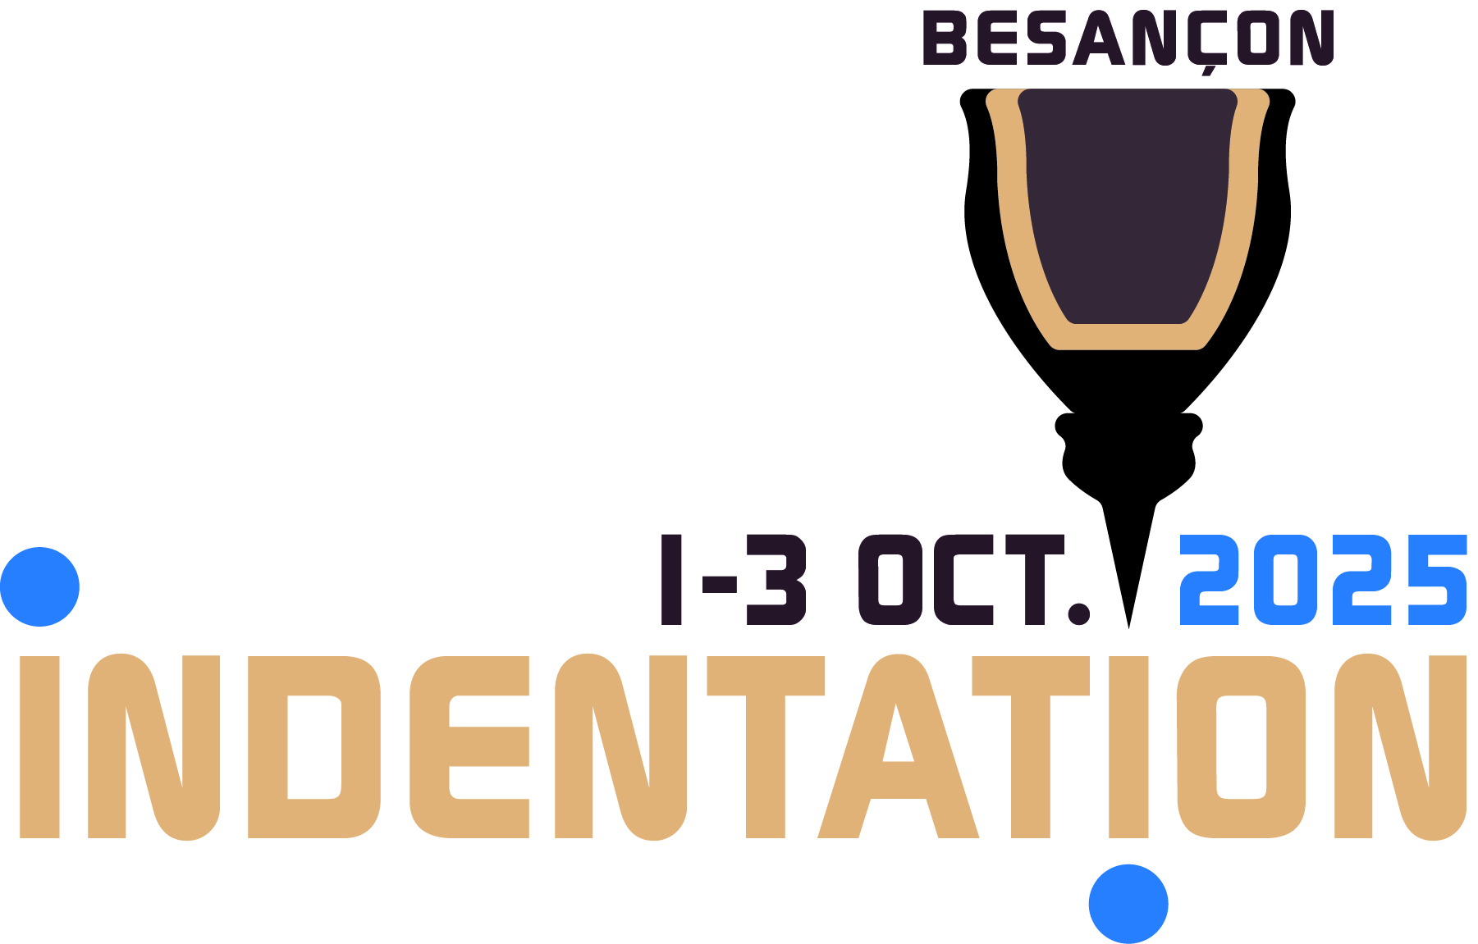
Indentation 2025 – Besançon – France
Groupe d’Indentation Multi Echelles

TITLE
A. Author^{1 (*)}, B. Author ², C. Author³ et D. Author ^{1,2}
1 : affiliation 1
2 : affiliation 2
3 : affiliation 3
^{(*)} corresponding author e-mail

Abstract - The following instructions are for authors who wish to present an oral or poster communication at the conference. The length of the abstract is 2 pages, including one figure.
Accepted abstracts will be published electronically and archived on https://hal.science/

Keywords - 1 to 4 keywords for indexing purposes, separated by commas.

ABSTRACT

The abstract is written in calibri font, 10 point size.

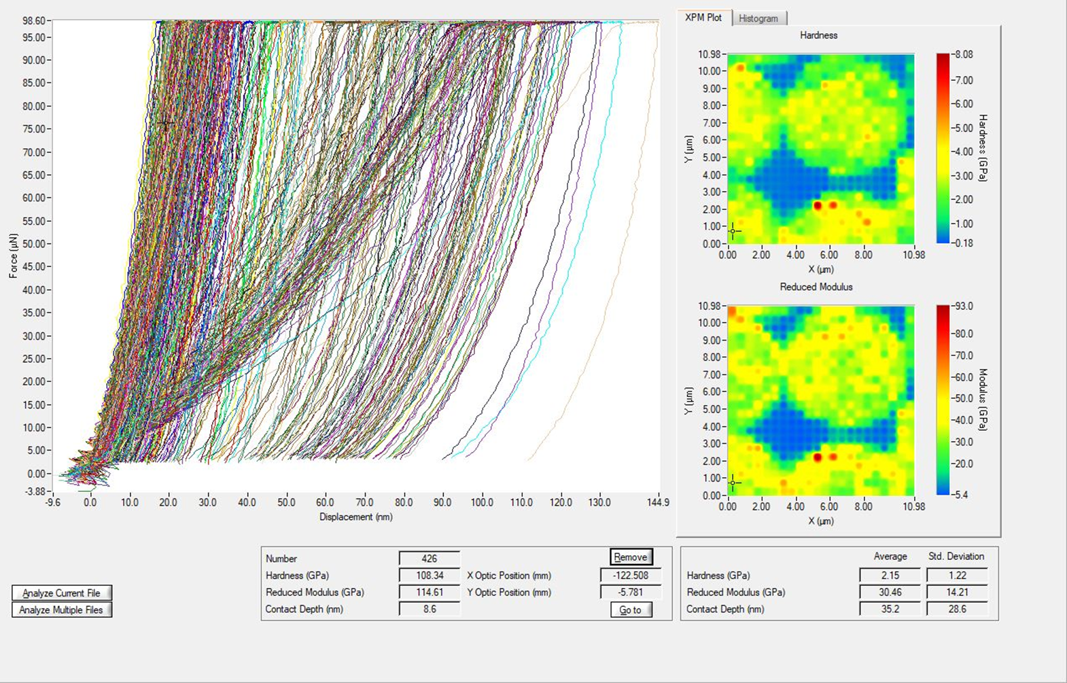
Figure 1 – titre de la figure

Acknowledgements

Références
[1] A. Author et B. Author, Title of the article, Journal publication, xx, pages 0000-0000, year
[2] A. Author et B. Author, Title of the article, Journal publication, xx, pages 0000-0000, year

